**THE TRAGEDY OF FLIGHT**

**A COMPREHENSIVE CRASH ANALYSIS**

**1. INTRODUCTION:**

An air crash accident is defined by the Convention on International Civil Aviation Annex 13 as an occurrence associated with the operation of an aircraft, which takes place from the time any person boards the aircraft with the intention of flight until all such persons have disembarked, and in which a person is fatally or seriously injured, the aircraft sustains significant damage or structural failure, or the aircraft goes missing or becomes completely inaccessible.

Aviation accident analysis is performed to determine the cause of errors once an accident has happened. In the modern aviation industry, it is also used to analyze a database of past accidents in order to prevent an accident from happening. Many models have been used not only for the accident investigation but also for educational purpose. The analysis of air crash from 1908 to 2009 is studied in this project.

**2.PROBLEM DEFINITION AND DESIGN THINKING**

EMPATHY MAP

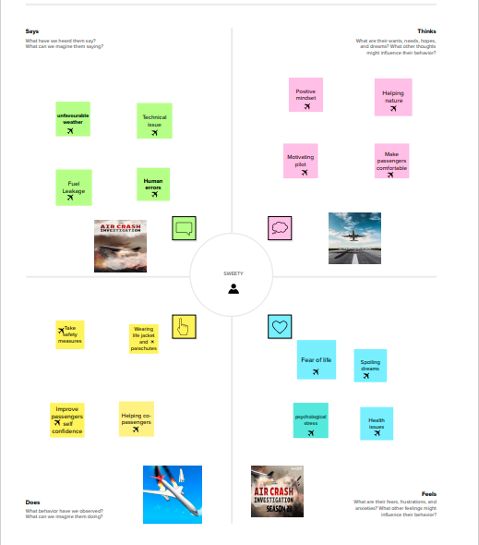

IDEATION AND BRAINSTORMING MAP

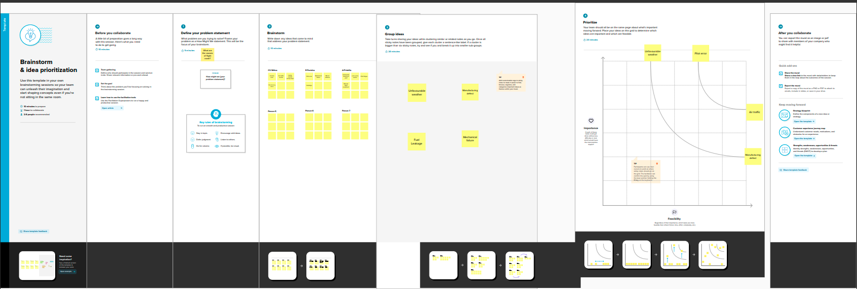

3.RESULT

DASHBOARD 1

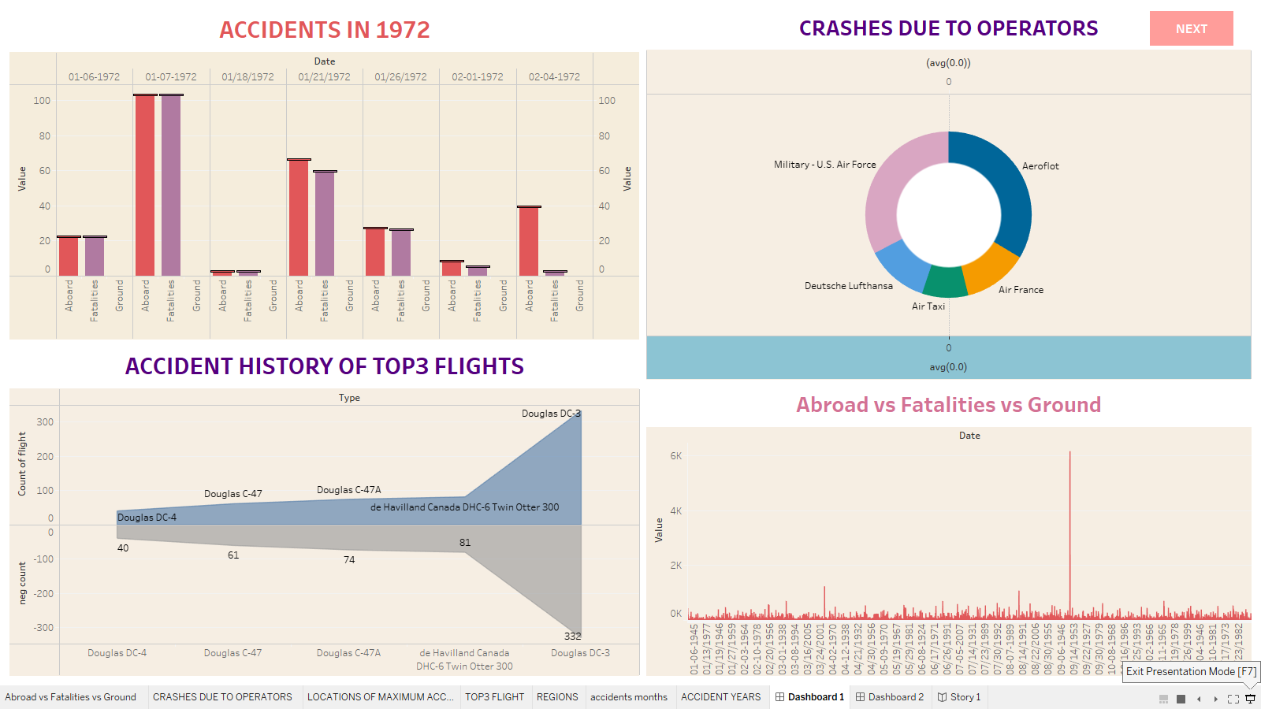

DASHBOARD 2

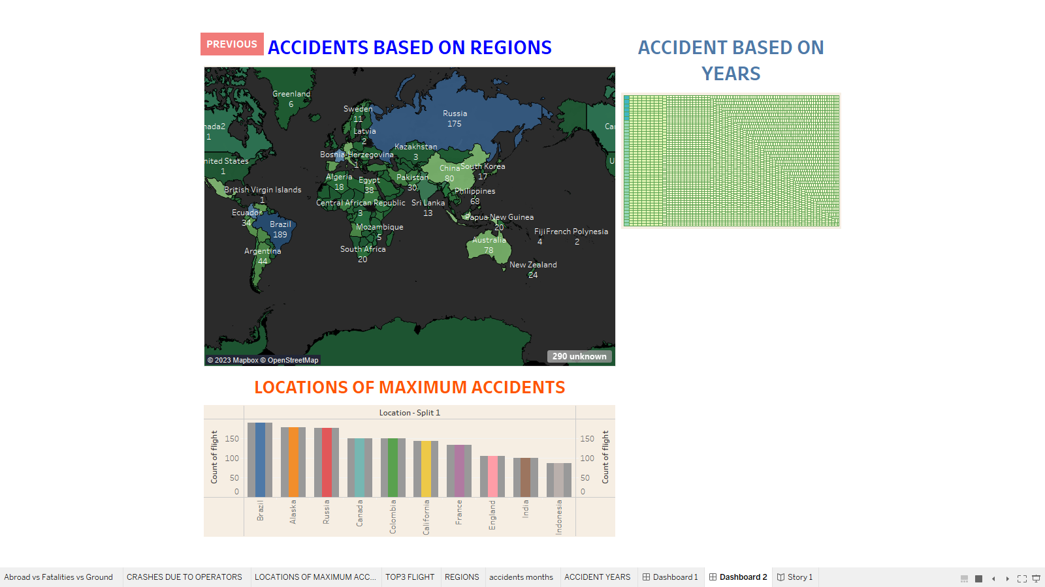

STORY

1.

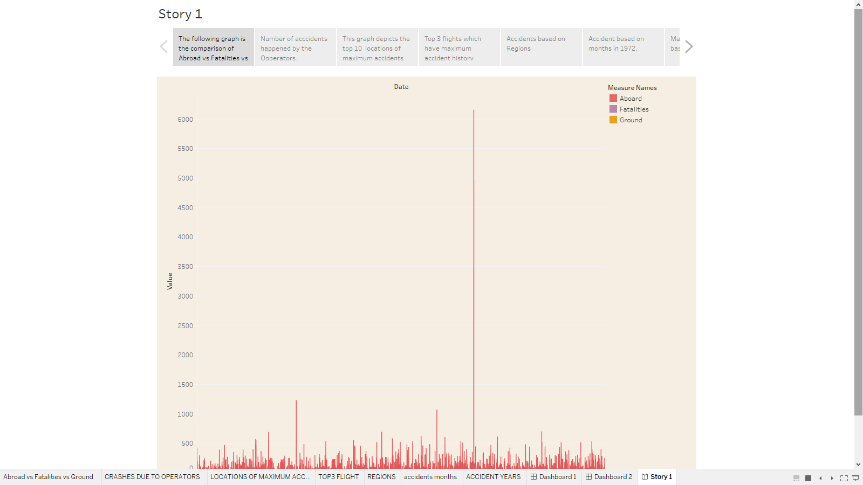

2.

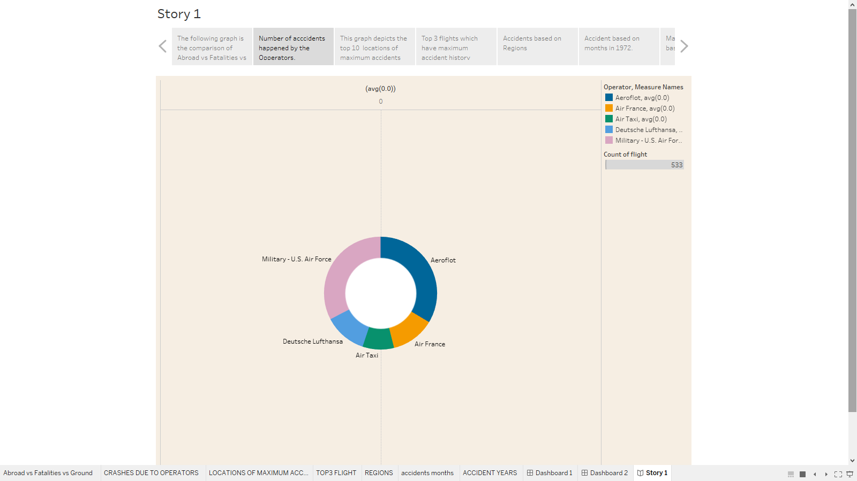

3.

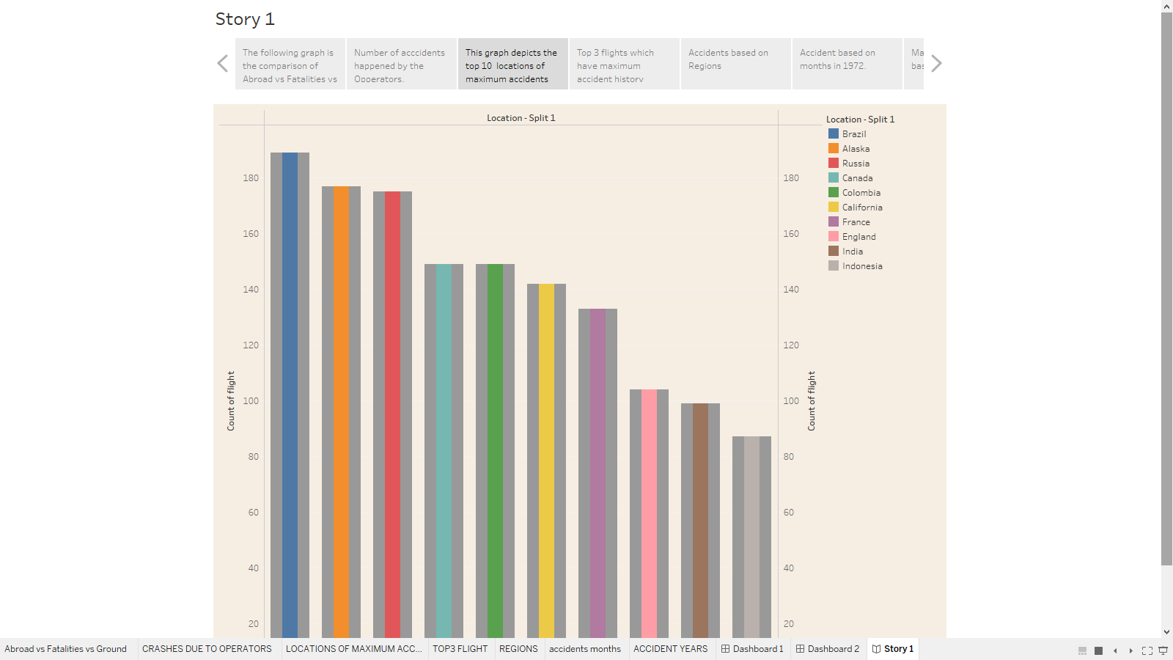

4.

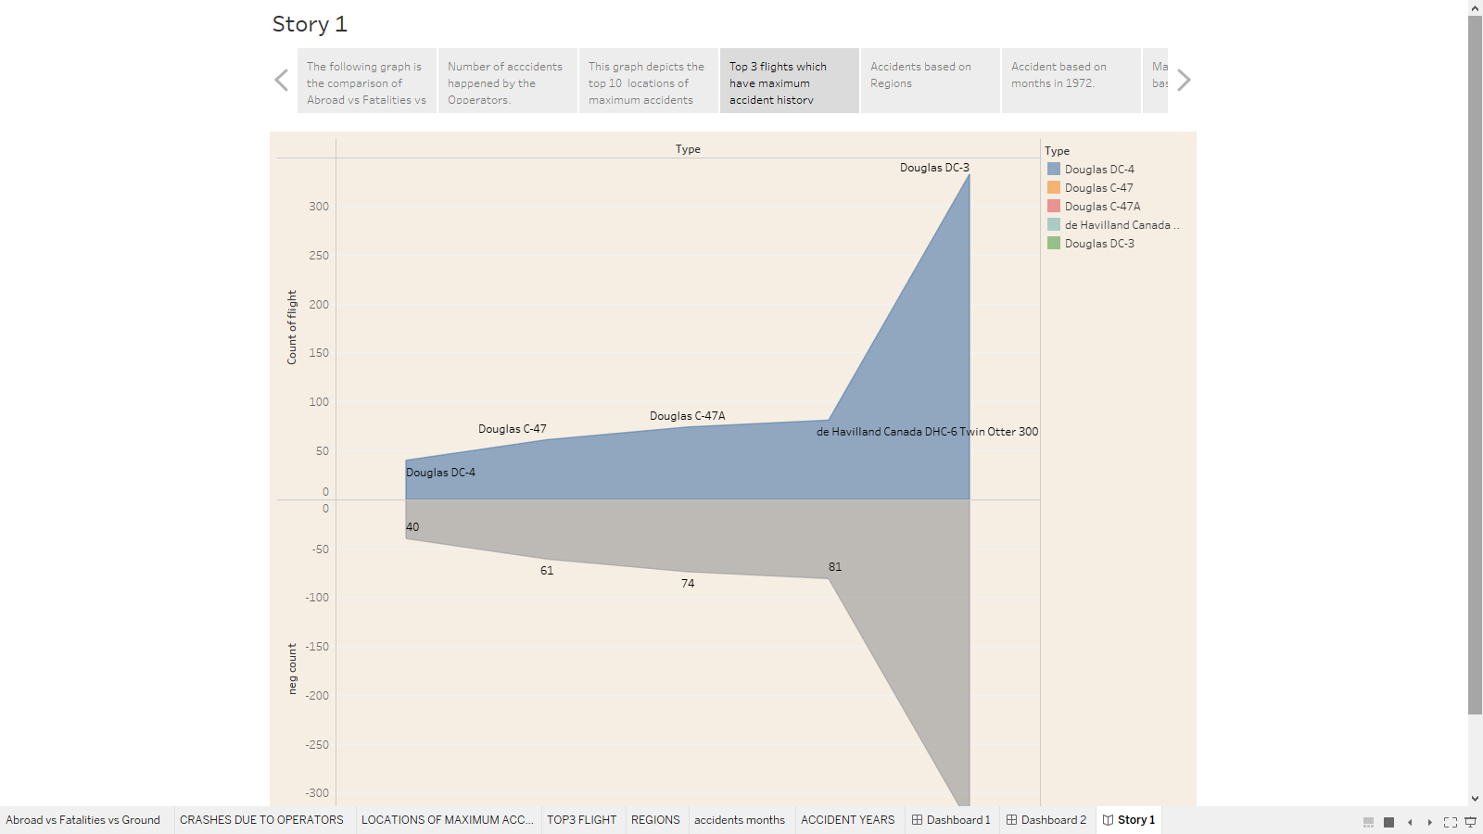

5.

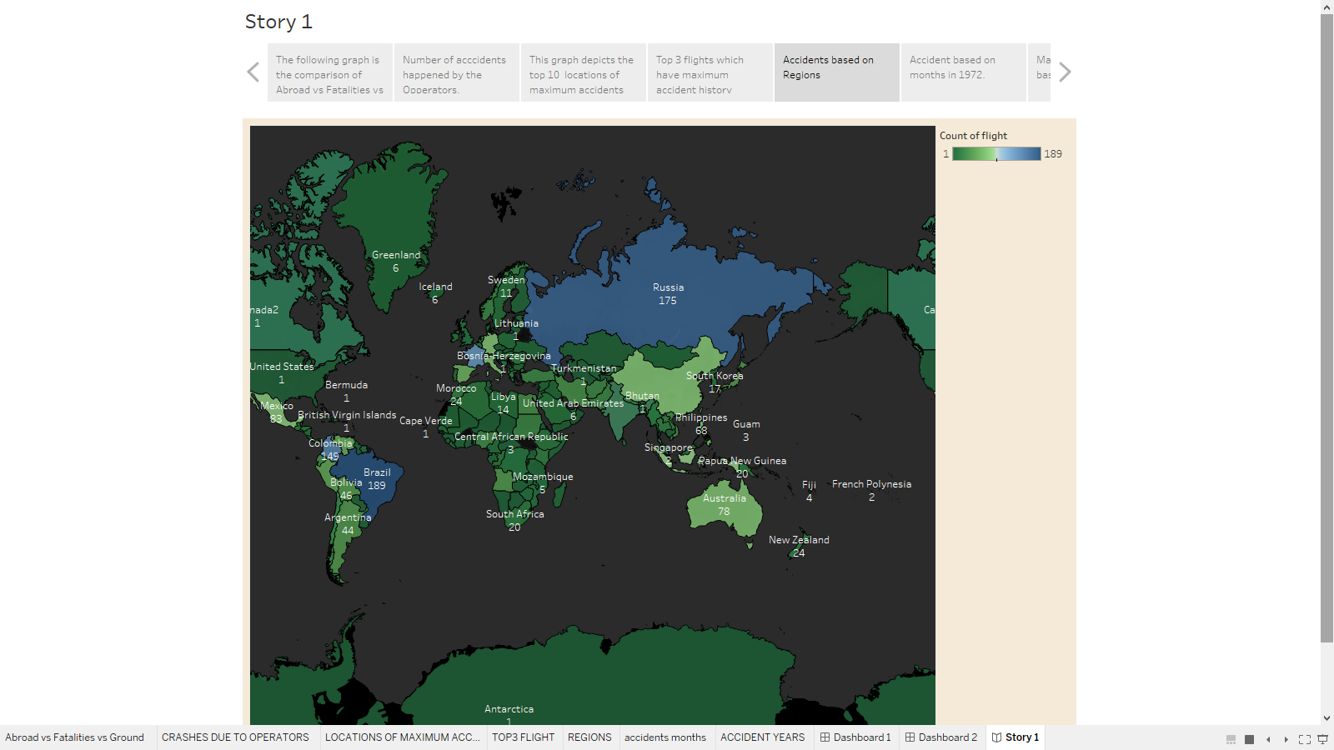

6.

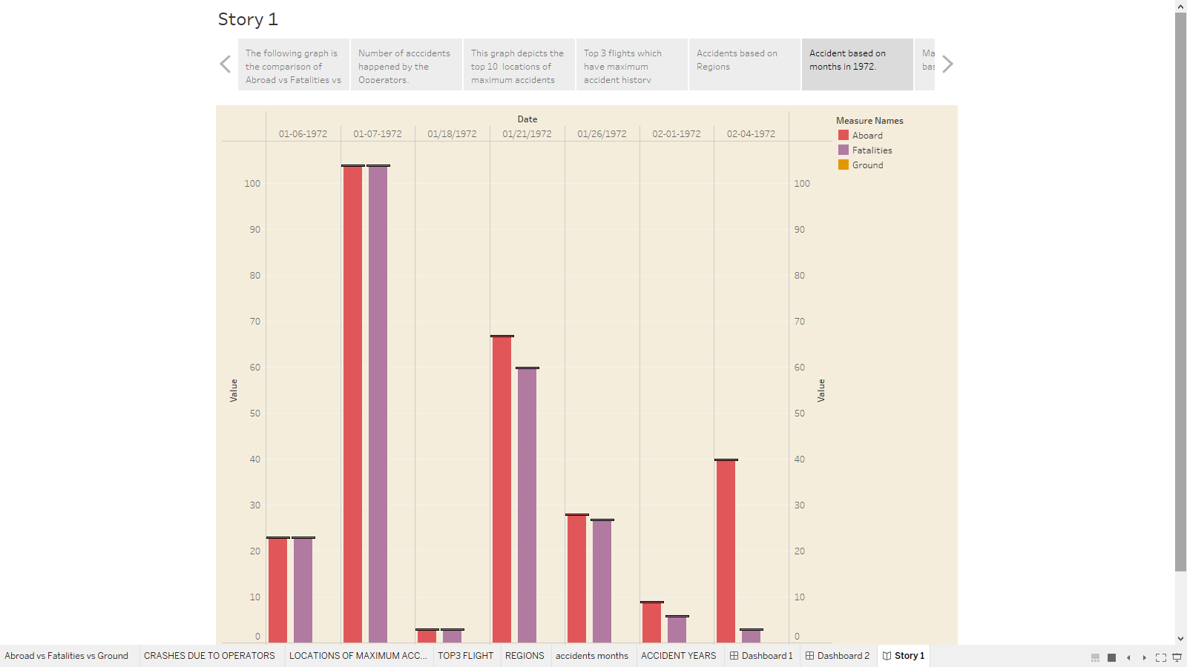

7.

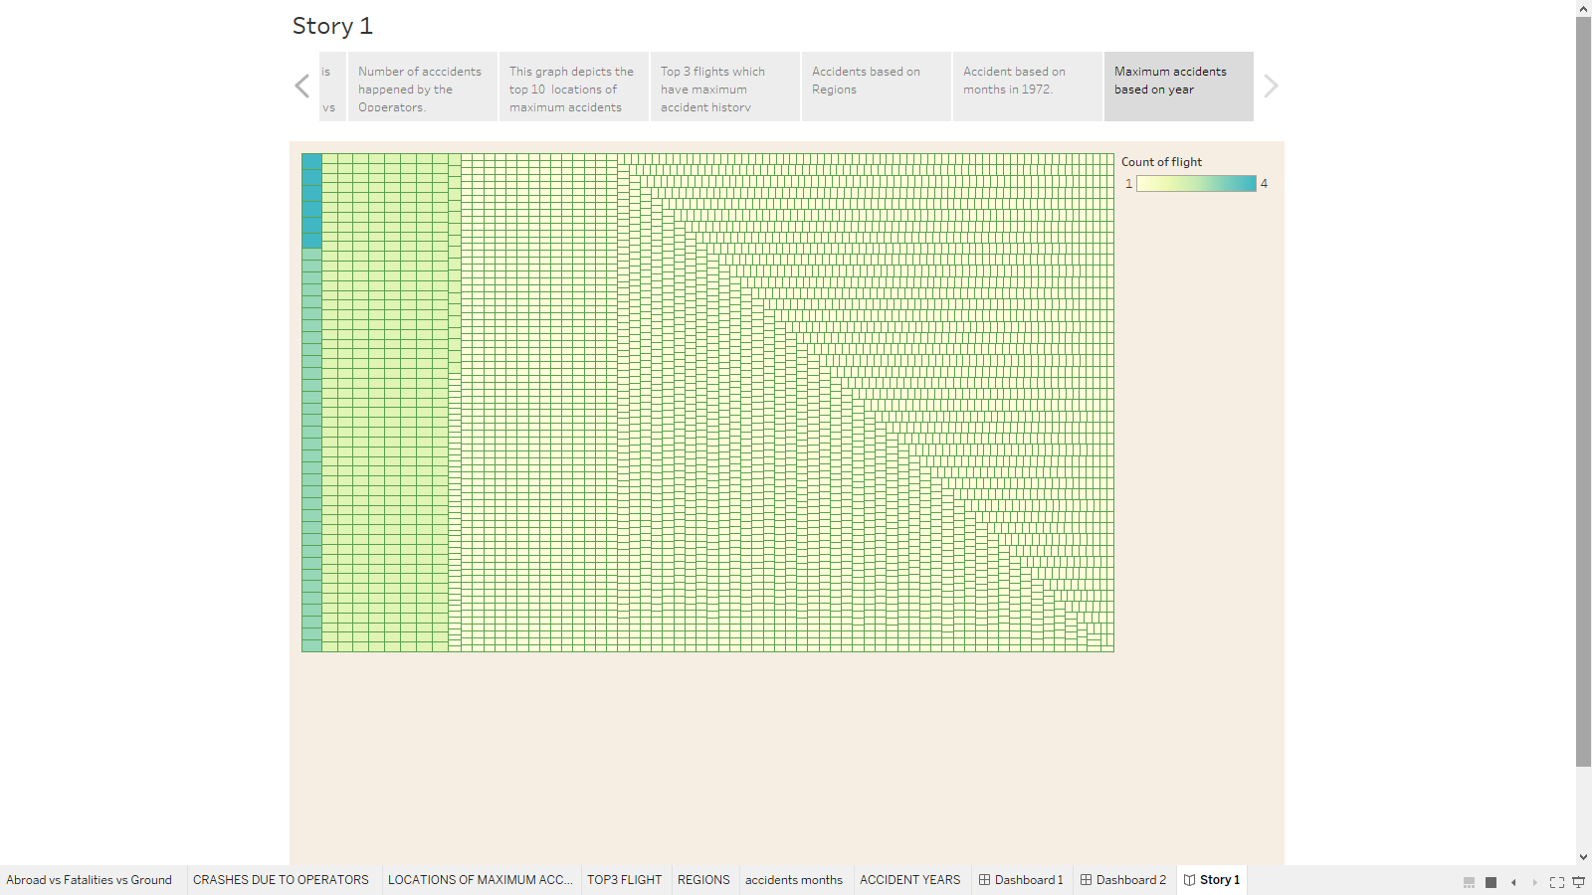

4.ADVANTAGES OF AIR CRASH ANALYSIS

In drawing up the aircraft accident analysis it helped us to make a detailed study of accidents due to any one cause. If all the accidents are classified according to the graphs presented here major causes can be easily determined and further investigation can be carried out for the purpose of eliminating these causes. It is helpful to effectively discover the hazards that led to the accident and to prevent their recurrence in a future accident or incident. It enables employers and workers to identify and implement the corrective actions necessary to prevent future incidents.

Analysis of air crash is widely used by air craft operators throughout the world to inform and facilitate corrective actions in a range of operational areas by offering the ability to track and evaluate flight operations trends, identify risk precursors, and take the appropriate remedial action. So flight Crash analysis is helpful to reduce and stop air crashes in the future.

**5. APPLICATIONS**

The main purpose of air crash analysis is to determine the cause of the crash and any contributing factors involved in the crash. These analysis also provide recommendations for safe operations.

Analysis of the flight assist an operator to identify, quantify, access and address operational risks. It can be effectively used t support a range of airworthiness and operational safety tasks.

In the modern aviation industry, it is also used to analyze a database of past accidents in order to prevent an accident from happening.

Analysis also helpful in identifying what happened during an outage, discovering things like who and what parts if the system were involved, and how the problem was handled. The purpose of analysis is to understand the casual factors that trigger substandard safety performance within a particular event, whether the event is miserable.

**6. CONCLUSION**

The goal of data visualization is to make complex data sets more accessible and easier to interpret. By using visual elements such as charts, graphs, and maps, data visualization can help people quickly understand the data and identify patterns, trends, and outliers in the data.

The Analysis done shows various aspects of a flight accident. It compares the aboard vs fatalities vs ground. It shows the maximum accidents based on years, Also based on months. Highest accidents happened by operators and top 10 locations that had more accidents, top 3 flight which have maximum accident history and also accidents based on regions.

From the data visualization graphs it is found that the maximum accidents were occurred in the year 1972. And the accidents based on the months of 1972 are drawn using graphs. Highest number of accidents by operators includes Military-US Air force, Aero float, Air taxi, Air France and Deutshe Lufthansa.

Douglas DC-4, Douglas C-47, Douglas C-47A are the top 3 flights that have maximum accident history. The flight crash accidents based on regions is shown using the geographical representation of the data visualization.

**7. FUTURE SCOPE**

Data analytics is the process of exploring and analyzing large datasets to find hidden patterns, unseen trends, discover correlations, and derive valuable insights to make business predictions. It improves the speed and efficiency of your business.

In the aviation sector Tons of sensors are installed in the parts of the planes like on wings (pressure sensors and temperature sensors) in the turbines, we can analyze how plane is working. By pooling the data together and from the accidents occurred data at what temperature and pressures, most probable locations and time for bird strikes we can take proper precautions from it.

The aviation sector generates a huge volume of data and wherever there is data, there is a definite scope for data analytics. From the time you search fir the cheapest airfare to book your airline ticket, opting for services like web check in to actual travel social media updates and airports reviews, the data trial you leave behind almost is unimaginable.

All this data may not mean much while you look at it, but advanced analytics make use of these data and provide a well analysis of the passengers. Almost 59 percent of airport were investing in advanced analytic solutions. This opens up job opportunities in the aviation sector for big data analysts and data scientists for both the Indian sector and the global aviation sector.